**How to Install and Set Up an AWS CloudWatch Agent with metrices.**

CloudWatch is a handy feature that helps with event correlation and is critical in maintaining visibility within your technical infrastructure.

Prerequisites: -  
An AWS account.  
IAM user with AWS management console access.  
IAM permission is required to perform IAM, EC2, and CloudWatch activities.  
  
  
**Run the following commands at the console to download and install the Amazon CloudWatch agent on target machine:**

wget https://s3.amazonaws.com/amazoncloudwatch-agent/debian/amd64/latest/amazon-cloudwatch-agent.deb

sudo dpkg -i -E ./amazon-cloudwatch-agent.deb

Download and install the collectd daemon:

sudo apt-get update && sudo apt-get install collectd

**Create the Amazon CloudWatch configuration file by running the Amazon CloudWatch configuration wizard:**

sudo /opt/aws/amazon-cloudwatch-agent/bin/amazon-cloudwatch-agent-config-wizard  
  
Create an AWS credentials file with the AWS access key ID and shared access key at /home/.aws/credentials with the following content. Replace the AWS-ACCESS-KEY-ID and AWS-SECRET-ACCESS-KEY placeholders with the keys obtained in the previous step:

sudo apt install awscli

aws –version

aws configure

[default]

aws_access_key_id=AWS-ACCESS-KEY-ID

aws_secret_access_key=AWS-SECRET-ACCESS-KEY

Edit the common configuration file for the Amazon CloudWatch agent at /opt/aws/amazon-cloudwatch-agent/etc/common-config.toml and specify the path to the credentials file created in the previous step.

sudo vi /opt/aws/amazon-cloudwatch-agent/etc/common-config.toml

**Update the file with this content:**

[credentials]

shared_credential_file = "/home/bitnami/.aws/credentials"

**Start the Amazon CloudWatch agent with the following command:**

sudo /opt/aws/amazon-cloudwatch-agent/bin/amazon-cloudwatch-agent-ctl -a fetch-config -m ec2 -c file:/opt/aws/amazon-cloudwatch-agent/bin/config.json -s

**Check that the agent is running with the following command:**

sudo /opt/aws/amazon-cloudwatch-agent/bin/amazon-cloudwatch-agent-ctl -m ec2 -a status

**Check that the agent is running with the following command:**

sudo /opt/aws/amazon-cloudwatch-agent/bin/amazon-cloudwatch-agent-ctl -m ec2 -a status

[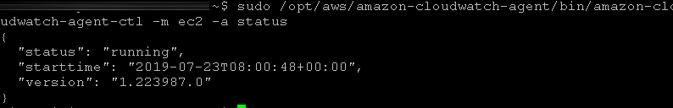](https://docs.bitnami.com/images/img/platforms/aws/cloudwatch-status.png)

**The steps above will also automatically configure the Amazon CloudWatch agent to automatically start on server reboot.**